Teacher : Eric Lindblom
Teacher in Charge : Eric Lindblom
Japanese  - JPN101 for 2016 |  | E-Mail: lindblome@opihicollege.school.nz  Phone: 03 615 7442  Room: 11 (Japanese Room)

Overview  Course Title and Level of Study  Japanese Level 1  Course Description  Students will develop the skills needed to understand and use spoken and written Japanese; communicate effectively in Japanese for authentic purposes; and learn the conventions of communicating in Japanese and develop an understanding of Japanese culture.  Assessment Guidelines  There are 5 Achievement Standards offered in this course. Each carries a weight of 4 or 5 credits with a total of 24 credits available in the course. Most students will be assessed against 4 or 5 standards.  3 of the 5 Achievement Standards are Internally Assessed (14 credits). These are assignment-based assessments, which you will complete during the course. The period of time available to complete the assignments will be clearly stated in the assessment documentation.  2 of the 5 Achievement Standards are Externally Assessed (10 credits). These are taught throughout the year. Practice assessments on completed standards will take place in Term 4.  Authenticity  All work submitted must be your own and follow procedures laid out in the Student NCEA Handbook. You must sign an authenticity declaration for your work to be accredited.  Pre-requisites for this course and for your next level of study  Admission to this course is dependent on reaching a satisfactory level in Year 10 Japanese. |  | Course Materials  - Kitto Dekiru 3, 4, 5, 6  - Ring Binder  - Language Perfect Account - $20  - KanjiPro Account - $8  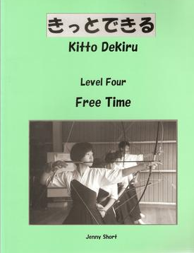  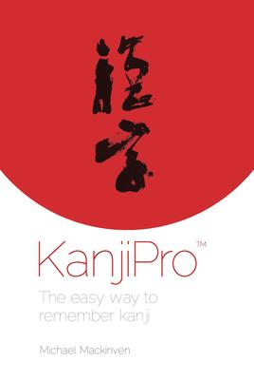  Tracking Progress  Standard Number: 90894  Standard Title: 1.2 Presentation  Grade:  Credits Achieved:  Standard Number: 90895  Standard Title: 1.3 Interaction  Grade:  Credits Achieved:  Standard Number: 90897  Standard Title: 1.5 Writing  Grade:  Credits Achieved:

Achievement Objectives
Level 6 of the Learning Languages Curriculum Achievement Objectives
The achievement objectives in the Communication strand provide the basis for assessment. The two supporting strands, Language knowledge and Cultural knowledge, are only assessed indirectly through their contribution to the Communication strand.

Communication
Proficiency descriptor – Students can understand and produce more complex language. They can communicate beyond the immediate context, for example, about past and future events. Students can understand and produce a variety of text types.

In selected linguistic and sociocultural contexts, students will:

Selecting and using language, symbols, and texts to communicate
• Communicate information, ideas, and opinions through different text types.

Managing self and relating to others
• Express and respond to personal ideas and opinions.

Participating and contributing in communities
• Communicate appropriately in different situations.
Cultural knowledge
Students will:
• Understand ways in which the Japanese culture is organised for different purposes.
Language knowledge
Students will:
• Understand ways in which the Japanese language is organised for different purposes.

Standard Course Outline:
NQF Number | Ver # | Internal External | Full Title | Credits | Estimated Study Dates | Estimated Assessment Date or Project Deadline | Further assessment
90894  (1.2) | 2 | Internal | Presentation - Give a spoken presentation in Japanese that communicates a personal response. | 4 | Term 3  Weeks 5-10 | Due by end of Term 3 | Term 4
90895  (1.3) | 2 | Internal | Interaction - Interact using spoken Japanese to communicate personal information, ideas and opinions in different situations. | 5 | Term 2 – Term 3 | Due by end of Term 3 | None
90897  (1.5) | 2 | Internal | Writing - Write a variety of text types in Japanese on areas of most immediate relevance. | 5 | Term 2 – Term 3 | Due by end of Term 3 | None
90893  (1.1) | 2 | External | Listening - Demonstrate understanding of a variety of spoken Japanese texts on areas of most immediate relevance. | 5 | All Year | External Exam | None
90896  (1.4) | 2 | External | Reading and Viewing - Demonstrate understanding of a variety of Japanese texts on areas of most immediate relevance. | 5 | All Year | External Exam | None

Revision Programme:
A revision programme for External Preparation will be available in Term 4.

