Teacher : Eric Lindblom
Teacher in Charge : Eric Lindblom
Japanese  - JPN201 for 2016 |  | E-Mail: lindblome@opihicollege.school.nz  Phone: 03 615 7442  Room: 11 (Japanese Room)

Overview  Course Title and Level of Study  Japanese Level 2  Course Description  Students will develop the skills needed to understand and use spoken and written Japanese; communicate effectively in Japanese for authentic purposes; and learn the conventions of communicating in Japanese and develop an understanding of Japanese culture.  Assessment Guidelines  There are 5 Achievement Standards offered in this course. Each carries a weight of 4 or 5 credits with a total of 24 credits available in the course. Most students will be assessed against 4 or 5 standards.  3 of the 5 Achievement Standards are Internally Assessed (14 credits). These are assignment-based assessments, which you will complete during the course. The period of time available to complete the assignments will be clearly stated in the assessment documentation.  2 of the 5 Achievement Standards are Externally Assessed (10 credits). These are taught throughout the year. Practice assessments on completed standards will take place in Term 4.  Authenticity  All work submitted must be your own and follow procedures laid out in the Student NCEA Handbook. You must sign an authenticity declaration for your work to be accredited.  Pre-requisites for this course and for your next level of study  Admission to this course is dependent on reaching a satisfactory level in Year 11 Japanese. |  | Course Materials  - Erin ga Chosen  - Ring Binder  - Language Perfect Account - $20  - KanjiPro Account - $8  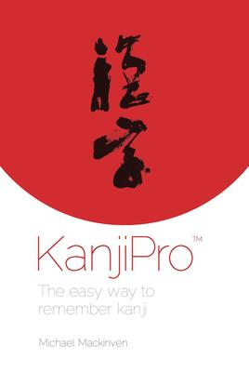  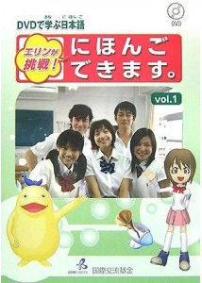  Tracking Progress  Standard Number: 91135  Standard Title: 2.2 Presentation  Grade:  Credits Achieved:  Standard Number: 91134  Standard Title: 2.3 Interaction  Grade:  Credits Achieved:  Standard Number: 91137  Standard Title: 2.5 Writing  Grade:  Credits Achieved:

Achievement Objectives
Level 7 of the Learning Languages Curriculum Achievement Objectives
The achievement objectives in the Communication strand provide the basis for assessment. The two supporting strands, Language knowledge and Cultural knowledge, are assessed indirectly through their contribution to the Communication strand.

Communication
Proficiency descriptor – Students can use language variably and effectively to express and justify their own ideas and opinions and support or challenge those of others. They are able to use and identify the linguistic and cultural forms that guide interpretation and enable them to respond critically to texts.

In selected linguistic and sociocultural contexts, students will:

Selecting and using language, symbols, and texts to communicate
• Communicate information, ideas, and opinions through increasingly complex and varied texts.

Managing self and relating to others
• Explore the views of others, developing and sharing personal perspectives.

Participating and contributing in communities
• Engage in sustained interaction and produce extended text.
Cultural knowledge
Students will:
• Analyse ways in which the Japanese culture is organised for different purposes and for different audiences.
• Analyse how the use of the target language expresses cultural meanings.
Language knowledge
Students will:
• Analyse ways in which the Japanese language is organised in different texts and for different purposes.
• Explore how linguistic meaning is conveyed across languages.

Standard Course Outline:
NQF Number | Ver # | Internal External | Full Title | Credits | Estimated Study Dates | Estimated Assessment Date or Project Deadline | Further assessment
91135  (2.2) | 2 | Internal | Presentation - Give a spoken presentation in Japanese that communicates information, ideas and opinions. | 4 | Term 3  Weeks 5-10 | Due by end of Term 3 | Term 4
91134  (2.3) | 2 | Internal | Interaction - Interact using spoken Japanese to share information and justify ideas and opinions in different situations. | 5 | Term 2 – Term 3 | Due by end of Term 3 | None
91137  (2.5) | 2 | Internal | Writing - Write a variety of text types in Japanese to convey information, ideas, and opinions in genuine contexts. | 5 | Term 2 – Term 3 | Due by end of Term 3 | None
91133  (2.1) | 2 | External | Listening - Demonstrate understanding of a variety of spoken Japanese texts on areas of most immediate relevance. | 5 | All Year | External Exam | None
91136  (2.4) | 2 | External | Reading and Viewing - Demonstrate understanding of a variety of written and/or visual Japanese text(s) on familiar matters. | 5 | All Year | External Exam | None

Revision Programme:
A revision programme for External Preparation will be available in Term 4.

