Visual Art Stationery 2018
Opihi College Art department is pleased to be able to offer Stationery for Art subjects at very competitive prices! The following lists show stationery that students can order for Term 1, 2016. Please drop order forms and money into the front office during or before Week 1, Term 1 (2016). Please note: Junior students can recycle visual diaries from their previous year.
Year 7 and 8 Art – One Term | Visual Diary A4, 2 x HB Pencils
Year 9 Art – Two Terms | Visual Diary A3, 2 x HB Pencils
Year 10 Art – Full Year | Visua  l Diary A3, 2 x HB, 2B, 4B and 6B Pencils
Year 11 Art – Full Year NCEA | Visual Diary A3, A3 Clearfile, 2 x HB, 2B, 4B and 6B Pencils
Year 12 and 13 Design or Photography NCEA Level 2 & 3 | Visual Diary A3 and A3 Clearfile
Year 12 and 13 Paint | Visual Diary A3, A3 Clearfile, Paints and Paint Brushes
Year 12 and 13 Print | Visual Diary A3, A3 Clearfile
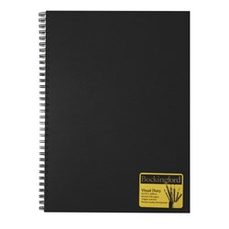
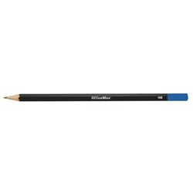
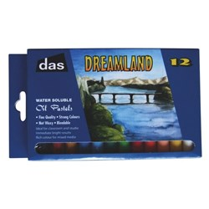

Pencils
$1.10 each

Oil Pastels
$7.00 each

Visual Diary A3
$12.50 each

Visual Diary A4
$7.50 each

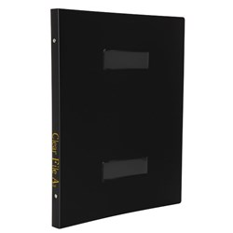
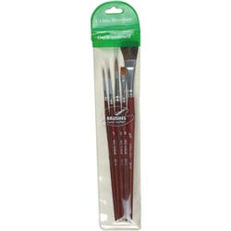
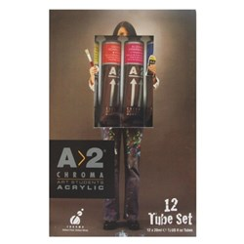

A3 Clearfile
$18.00 each

Paints
$20.00 each

Paint Brushes
$15.00 each

Student Name:_________________________________________________ Year: _____________________
Item | Price | Quantity | Total
Visual Diary A4 | $7.50
Visual Diary A3 | $12.50
A3 Clearfile | $18.00
Pencils: HB | $1.10
Pencils: 2B | $1.10
Pencils: 4B | $1.10
Pencils: 6B | $1.10
Oil Pastel | $7.00
Brushes (set 5) | $15.00
A2 Chroma acrylic paint | $20.00
 |  | TOTAL

